1 run......

Downloading: 100%

445M/445M [00:19<00:00, 23.9MB/s]

training 1 epoch...

30.308626174926758 seconds used......

1 training finished! average train loss: 0.7321537435054779

evaluating...

Confusion matrix, without normalization

[[ 46 36 14]

[ 20 274 61]

[ 23 84 612]]

Normalized confusion matrix

[[0.47916667 0.375 0.14583333]

[0.05633803 0.77183099 0.17183099]

[0.03198887 0.11682893 0.8511822 ]]

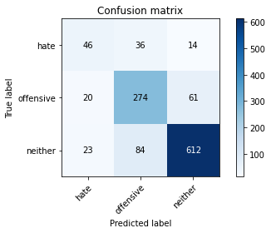

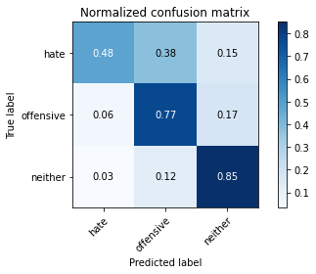

precision recall f1-score support

hate 0.52 0.48 0.50 96

offensive 0.70 0.77 0.73 355

neither 0.89 0.85 0.87 719

accuracy 0.80 1170

macro avg 0.70 0.70 0.70 1170

weighted avg 0.80 0.80 0.80 1170

average eval_loss: 0.5050468611515174, accuracy: 0.7965811965811965

training 2 epoch...

29.379905223846436 seconds used......

2 training finished! average train loss: 0.3960383429359167

evaluating...

Confusion matrix, without normalization

[[ 52 27 17]

[ 16 260 79]

[ 9 77 633]]

Normalized confusion matrix

[[0.54166667 0.28125 0.17708333]

[0.04507042 0.73239437 0.22253521]

[0.01251739 0.10709318 0.88038943]]

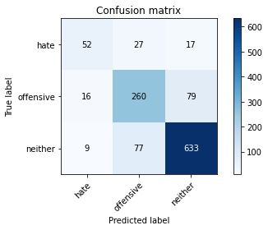

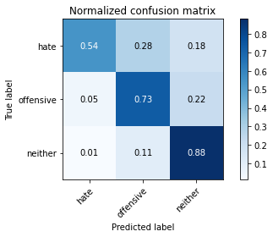

precision recall f1-score support

hate 0.68 0.54 0.60 96

offensive 0.71 0.73 0.72 355

neither 0.87 0.88 0.87 719

accuracy 0.81 1170

macro avg 0.75 0.72 0.73 1170

weighted avg 0.81 0.81 0.81 1170

average eval_loss: 0.4760644616464437, accuracy: 0.8076923076923077

training 3 epoch...

29.558021783828735 seconds used......

3 training finished! average train loss: 0.18030554095569712

evaluating...

Confusion matrix, without normalization

[[ 61 28 7]

[ 30 285 40]

[ 41 129 549]]

Normalized confusion matrix

[[0.63541667 0.29166667 0.07291667]

[0.08450704 0.8028169 0.11267606]

[0.05702364 0.17941586 0.7635605 ]]

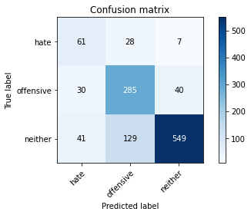

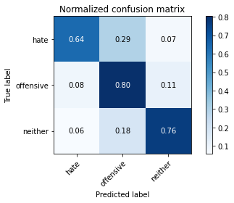

precision recall f1-score support

hate 0.46 0.64 0.54 96

offensive 0.64 0.80 0.72 355

neither 0.92 0.76 0.83 719

accuracy 0.76 1170

macro avg 0.68 0.73 0.70 1170

weighted avg 0.80 0.76 0.77 1170

average eval_loss: 0.7397603445639045, accuracy: 0.7649572649572649

training 4 epoch...

29.582683086395264 seconds used......

4 training finished! average train loss: 0.0824012382624623

evaluating...

Confusion matrix, without normalization

[[ 67 17 12]

[ 56 230 69]

[ 33 60 626]]

Normalized confusion matrix

[[0.69791667 0.17708333 0.125 ]

[0.15774648 0.64788732 0.1943662 ]

[0.04589708 0.08344924 0.87065369]]

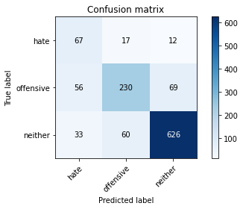

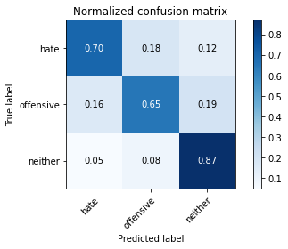

precision recall f1-score support

hate 0.43 0.70 0.53 96

offensive 0.75 0.65 0.69 355

neither 0.89 0.87 0.88 719

accuracy 0.79 1170

macro avg 0.69 0.74 0.70 1170

weighted avg 0.81 0.79 0.79 1170

average eval_loss: 0.746544950310204, accuracy: 0.7888888888888889

training 5 epoch...

29.473740100860596 seconds used......

5 training finished! average train loss: 0.044755009752966896

evaluating...

Confusion matrix, without normalization

[[ 53 21 22]

[ 26 234 95]

[ 10 46 663]]

Normalized confusion matrix

[[0.55208333 0.21875 0.22916667]

[0.07323944 0.65915493 0.26760563]

[0.01390821 0.06397775 0.92211405]]

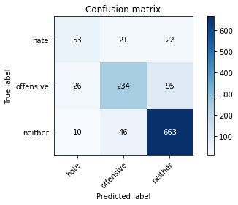

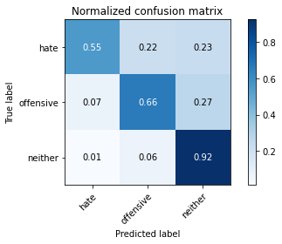

precision recall f1-score support

hate 0.60 0.55 0.57 96

offensive 0.78 0.66 0.71 355

neither 0.85 0.92 0.88 719

accuracy 0.81 1170

macro avg 0.74 0.71 0.72 1170

weighted avg 0.81 0.81 0.81 1170

average eval_loss: 0.8001304326136991, accuracy: 0.811965811965812

training 6 epoch...

29.565988779067993 seconds used......

6 training finished! average train loss: 0.026461530962245516

evaluating...

Confusion matrix, without normalization

[[ 63 21 12]

[ 31 283 41]

[ 26 124 569]]

Normalized confusion matrix

[[0.65625 0.21875 0.125 ]

[0.08732394 0.7971831 0.11549296]

[0.03616134 0.17246175 0.79137691]]

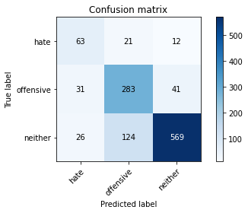

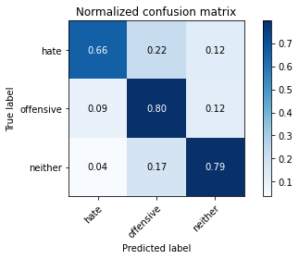

precision recall f1-score support

hate 0.53 0.66 0.58 96

offensive 0.66 0.80 0.72 355

neither 0.91 0.79 0.85 719

accuracy 0.78 1170

macro avg 0.70 0.75 0.72 1170

weighted avg 0.81 0.78 0.79 1170

average eval_loss: 0.948555733440286, accuracy: 0.782051282051282

training 7 epoch...

29.49635672569275 seconds used......

7 training finished! average train loss: 0.029173605313423112

evaluating...

Confusion matrix, without normalization

[[ 49 37 10]

[ 17 301 37]

[ 21 142 556]]

Normalized confusion matrix

[[0.51041667 0.38541667 0.10416667]

[0.04788732 0.84788732 0.10422535]

[0.02920723 0.19749652 0.77329624]]

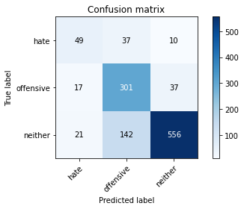

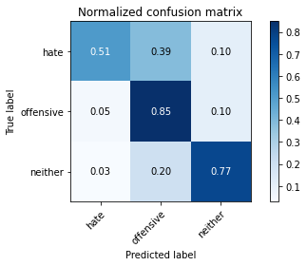

precision recall f1-score support

hate 0.56 0.51 0.54 96

offensive 0.63 0.85 0.72 355

neither 0.92 0.77 0.84 719

accuracy 0.77 1170

macro avg 0.70 0.71 0.70 1170

weighted avg 0.80 0.77 0.78 1170

average eval_loss: 1.0199368650377807, accuracy: 0.7743589743589744

training 8 epoch...

29.433565139770508 seconds used......

8 training finished! average train loss: 0.033200579480109856

evaluating...

Confusion matrix, without normalization

[[ 58 20 18]

[ 39 270 46]

[ 15 114 590]]

Normalized confusion matrix

[[0.60416667 0.20833333 0.1875 ]

[0.10985915 0.76056338 0.12957746]

[0.02086231 0.15855355 0.82058414]]

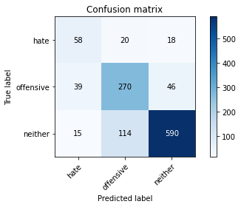

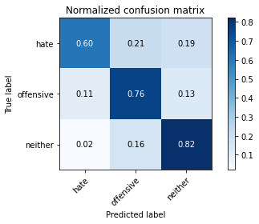

precision recall f1-score support

hate 0.52 0.60 0.56 96

offensive 0.67 0.76 0.71 355

neither 0.90 0.82 0.86 719

accuracy 0.78 1170

macro avg 0.70 0.73 0.71 1170

weighted avg 0.80 0.78 0.79 1170

average eval_loss: 0.9318950979544197, accuracy: 0.7846153846153846

training 9 epoch...

29.50267720222473 seconds used......

9 training finished! average train loss: 0.025351565775986858

evaluating...

Confusion matrix, without normalization

[[ 62 26 8]

[ 39 288 28]

[ 56 149 514]]

Normalized confusion matrix

[[0.64583333 0.27083333 0.08333333]

[0.10985915 0.81126761 0.07887324]

[0.07788595 0.20723227 0.71488178]]

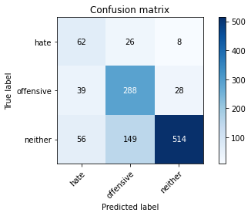

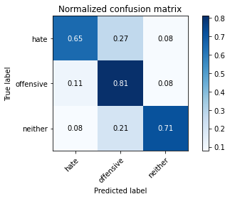

precision recall f1-score support

hate 0.39 0.65 0.49 96

offensive 0.62 0.81 0.70 355

neither 0.93 0.71 0.81 719

accuracy 0.74 1170

macro avg 0.65 0.72 0.67 1170

weighted avg 0.80 0.74 0.75 1170

average eval_loss: 1.2626286564489542, accuracy: 0.7384615384615385

training 10 epoch...

29.693923711776733 seconds used......

10 training finished! average train loss: 0.021725435498154137

evaluating...

Confusion matrix, without normalization

[[ 57 19 20]

[ 23 277 55]

[ 15 95 609]]

Normalized confusion matrix

[[0.59375 0.19791667 0.20833333]

[0.06478873 0.78028169 0.15492958]

[0.02086231 0.13212796 0.84700974]]

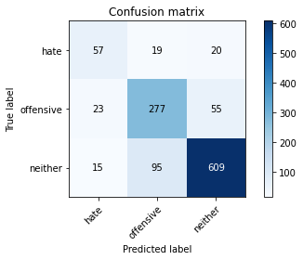

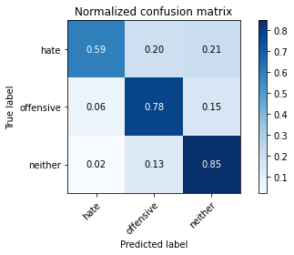

precision recall f1-score support

hate 0.60 0.59 0.60 96

offensive 0.71 0.78 0.74 355

neither 0.89 0.85 0.87 719

accuracy 0.81 1170

macro avg 0.73 0.74 0.74 1170

weighted avg 0.81 0.81 0.81 1170

average eval_loss: 0.9500586418908531, accuracy: 0.805982905982906

2 run......

training 1 epoch...

29.446115732192993 seconds used......

1 training finished! average train loss: 0.7768187442651162

evaluating...

Confusion matrix, without normalization

[[ 40 45 11]

[ 20 288 47]

[ 24 142 553]]

Normalized confusion matrix

[[0.41666667 0.46875 0.11458333]

[0.05633803 0.81126761 0.13239437]

[0.03337969 0.19749652 0.76912378]]

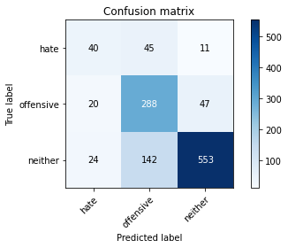

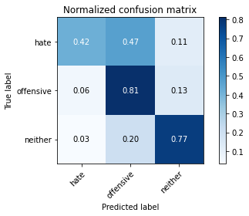

precision recall f1-score support

hate 0.48 0.42 0.44 96

offensive 0.61 0.81 0.69 355

neither 0.91 0.77 0.83 719

accuracy 0.75 1170

macro avg 0.66 0.67 0.66 1170

weighted avg 0.78 0.75 0.76 1170

average eval_loss: 0.564537278171313, accuracy: 0.752991452991453

training 2 epoch...

29.574195861816406 seconds used......

2 training finished! average train loss: 0.4504726034326431

evaluating...

Confusion matrix, without normalization

[[ 29 63 4]

[ 8 325 22]

[ 16 215 488]]

Normalized confusion matrix

[[0.30208333 0.65625 0.04166667]

[0.02253521 0.91549296 0.06197183]

[0.02225313 0.29902643 0.67872045]]

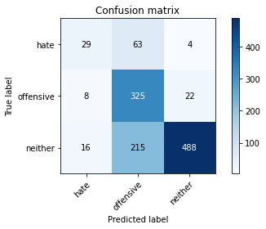

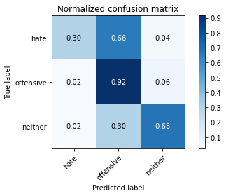

precision recall f1-score support

hate 0.55 0.30 0.39 96

offensive 0.54 0.92 0.68 355

neither 0.95 0.68 0.79 719

accuracy 0.72 1170

macro avg 0.68 0.63 0.62 1170

weighted avg 0.79 0.72 0.72 1170

average eval_loss: 0.7062255967471559, accuracy: 0.7196581196581197

training 3 epoch...

29.46351647377014 seconds used......

3 training finished! average train loss: 0.21361805056818786

evaluating...

Confusion matrix, without normalization

[[ 53 36 7]

[ 23 290 42]

[ 23 132 564]]

Normalized confusion matrix

[[0.55208333 0.375 0.07291667]

[0.06478873 0.81690141 0.11830986]

[0.03198887 0.18358832 0.78442281]]

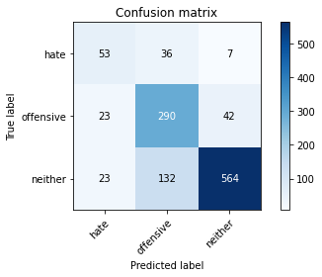

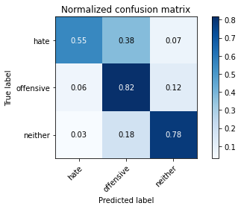

precision recall f1-score support

hate 0.54 0.55 0.54 96

offensive 0.63 0.82 0.71 355

neither 0.92 0.78 0.85 719

accuracy 0.78 1170

macro avg 0.70 0.72 0.70 1170

weighted avg 0.80 0.78 0.78 1170

average eval_loss: 0.6385500962703915, accuracy: 0.7752136752136752

training 4 epoch...

29.396811485290527 seconds used......

4 training finished! average train loss: 0.07972632909121995

evaluating...

Confusion matrix, without normalization

[[ 49 36 11]

[ 14 285 56]

[ 15 95 609]]

Normalized confusion matrix

[[0.51041667 0.375 0.11458333]

[0.03943662 0.8028169 0.15774648]

[0.02086231 0.13212796 0.84700974]]

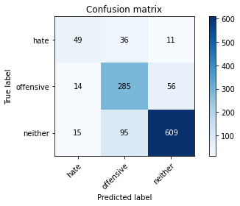

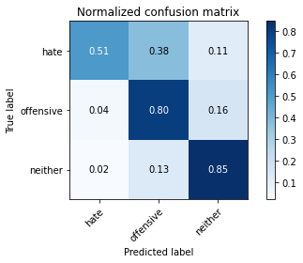

precision recall f1-score support

hate 0.63 0.51 0.56 96

offensive 0.69 0.80 0.74 355

neither 0.90 0.85 0.87 719

accuracy 0.81 1170

macro avg 0.74 0.72 0.73 1170

weighted avg 0.81 0.81 0.81 1170

average eval_loss: 0.6709160319513688, accuracy: 0.805982905982906

training 5 epoch...

29.424777269363403 seconds used......

5 training finished! average train loss: 0.04770182703400795

evaluating...

Confusion matrix, without normalization

[[ 66 19 11]

[ 45 247 63]

[ 19 86 614]]

Normalized confusion matrix

[[0.6875 0.19791667 0.11458333]

[0.12676056 0.69577465 0.17746479]

[0.02642559 0.11961057 0.85396384]]

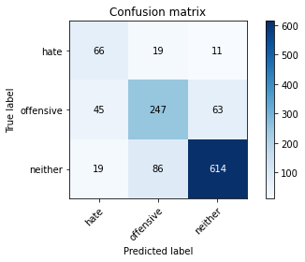

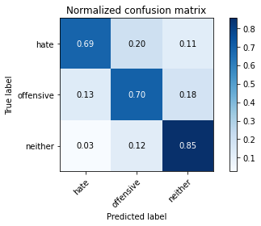

precision recall f1-score support

hate 0.51 0.69 0.58 96

offensive 0.70 0.70 0.70 355

neither 0.89 0.85 0.87 719

accuracy 0.79 1170

macro avg 0.70 0.75 0.72 1170

weighted avg 0.80 0.79 0.80 1170

average eval_loss: 0.8152548860190278, accuracy: 0.7923076923076923

training 6 epoch...

29.50176692008972 seconds used......

6 training finished! average train loss: 0.05061131885621506

evaluating...

Confusion matrix, without normalization

[[ 65 24 7]

[ 26 283 46]

[ 19 128 572]]

Normalized confusion matrix

[[0.67708333 0.25 0.07291667]

[0.07323944 0.7971831 0.12957746]

[0.02642559 0.17802503 0.79554937]]

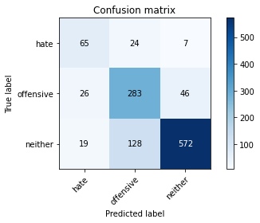

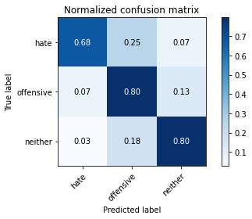

precision recall f1-score support

hate 0.59 0.68 0.63 96

offensive 0.65 0.80 0.72 355

neither 0.92 0.80 0.85 719

accuracy 0.79 1170

macro avg 0.72 0.76 0.73 1170

weighted avg 0.81 0.79 0.79 1170

average eval_loss: 0.797785824638302, accuracy: 0.7863247863247863

training 7 epoch...

29.504274606704712 seconds used......

7 training finished! average train loss: 0.03164730150549589

evaluating...

Confusion matrix, without normalization

[[ 70 22 4]

[ 35 291 29]

[ 46 155 518]]

Normalized confusion matrix

[[0.72916667 0.22916667 0.04166667]

[0.09859155 0.81971831 0.08169014]

[0.06397775 0.21557719 0.72044506]]

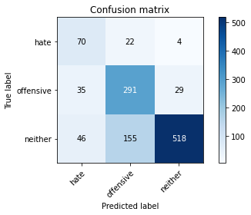

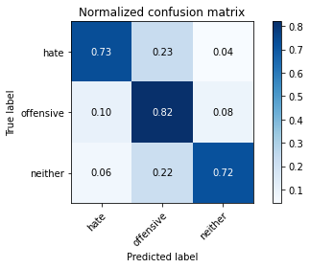

precision recall f1-score support

hate 0.46 0.73 0.57 96

offensive 0.62 0.82 0.71 355

neither 0.94 0.72 0.82 719

accuracy 0.75 1170

macro avg 0.68 0.76 0.70 1170

weighted avg 0.80 0.75 0.76 1170

average eval_loss: 1.0965142513356976, accuracy: 0.7512820512820513

training 8 epoch...

29.463228225708008 seconds used......

8 training finished! average train loss: 0.01973188023130672

evaluating...

Confusion matrix, without normalization

[[ 47 38 11]

[ 9 295 51]

[ 8 103 608]]

Normalized confusion matrix

[[0.48958333 0.39583333 0.11458333]

[0.02535211 0.83098592 0.14366197]

[0.01112656 0.14325452 0.84561892]]

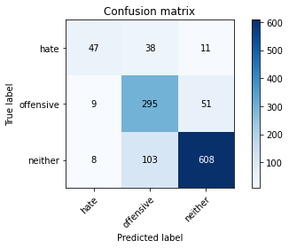

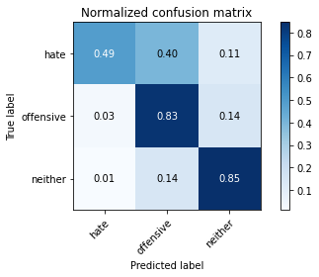

precision recall f1-score support

hate 0.73 0.49 0.59 96

offensive 0.68 0.83 0.75 355

neither 0.91 0.85 0.88 719

accuracy 0.81 1170

macro avg 0.77 0.72 0.74 1170

weighted avg 0.82 0.81 0.81 1170

average eval_loss: 0.9502950504390617, accuracy: 0.811965811965812

training 9 epoch...

29.441559314727783 seconds used......

9 training finished! average train loss: 0.019574611113057472

evaluating...

Confusion matrix, without normalization

[[ 43 48 5]

[ 11 306 38]

[ 11 148 560]]

Normalized confusion matrix

[[0.44791667 0.5 0.05208333]

[0.03098592 0.86197183 0.10704225]

[0.01529903 0.20584145 0.77885953]]

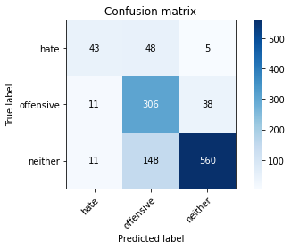

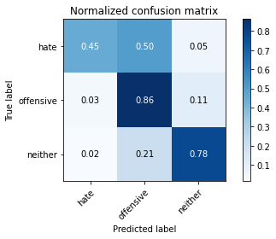

precision recall f1-score support

hate 0.66 0.45 0.53 96

offensive 0.61 0.86 0.71 355

neither 0.93 0.78 0.85 719

accuracy 0.78 1170

macro avg 0.73 0.70 0.70 1170

weighted avg 0.81 0.78 0.78 1170

average eval_loss: 1.1906840349942194, accuracy: 0.7769230769230769

training 10 epoch...

29.430187463760376 seconds used......

10 training finished! average train loss: 0.03795964661082671

evaluating...

Confusion matrix, without normalization

[[ 56 33 7]

[ 18 306 31]

[ 27 197 495]]

Normalized confusion matrix

[[0.58333333 0.34375 0.07291667]

[0.05070423 0.86197183 0.08732394]

[0.03755216 0.27399166 0.68845619]]

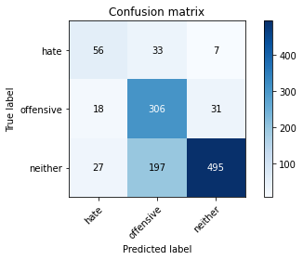

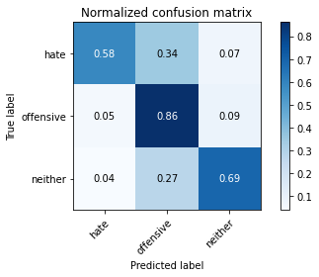

precision recall f1-score support

hate 0.55 0.58 0.57 96

offensive 0.57 0.86 0.69 355

neither 0.93 0.69 0.79 719

accuracy 0.73 1170

macro avg 0.68 0.71 0.68 1170

weighted avg 0.79 0.73 0.74 1170

average eval_loss: 1.3086253200042046, accuracy: 0.7324786324786324

3 run......

training 1 epoch...

29.418941497802734 seconds used......

1 training finished! average train loss: 0.7702191466322312

evaluating...

Confusion matrix, without normalization

[[ 29 55 12]

[ 5 295 55]

[ 10 147 562]]

Normalized confusion matrix

[[0.30208333 0.57291667 0.125 ]

[0.01408451 0.83098592 0.15492958]

[0.01390821 0.20445063 0.78164117]]

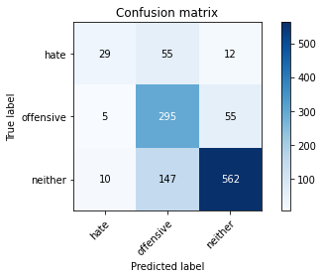

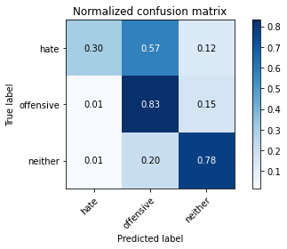

precision recall f1-score support

hate 0.66 0.30 0.41 96

offensive 0.59 0.83 0.69 355

neither 0.89 0.78 0.83 719

accuracy 0.76 1170

macro avg 0.72 0.64 0.65 1170

weighted avg 0.78 0.76 0.76 1170

average eval_loss: 0.5740297035140506, accuracy: 0.7572649572649572

training 2 epoch...

29.555697917938232 seconds used......

2 training finished! average train loss: 0.46901121597068435

evaluating...

Confusion matrix, without normalization

[[ 47 38 11]

[ 9 294 52]

[ 11 115 593]]

Normalized confusion matrix

[[0.48958333 0.39583333 0.11458333]

[0.02535211 0.82816901 0.14647887]

[0.01529903 0.15994437 0.82475661]]

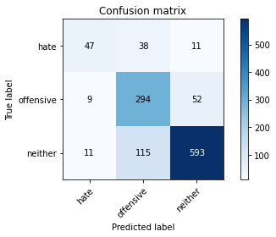

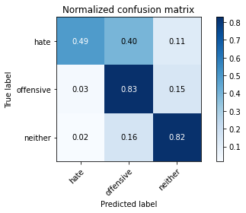

precision recall f1-score support

hate 0.70 0.49 0.58 96

offensive 0.66 0.83 0.73 355

neither 0.90 0.82 0.86 719

accuracy 0.80 1170

macro avg 0.75 0.71 0.72 1170

weighted avg 0.81 0.80 0.80 1170

average eval_loss: 0.488946650745505, accuracy: 0.7982905982905983

training 3 epoch...

29.463348150253296 seconds used......

3 training finished! average train loss: 0.23956256818312865

evaluating...

Confusion matrix, without normalization

[[ 48 26 22]

[ 14 245 96]

[ 4 48 667]]

Normalized confusion matrix

[[0.5 0.27083333 0.22916667]

[0.03943662 0.69014085 0.27042254]

[0.00556328 0.06675939 0.92767733]]

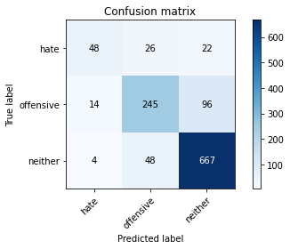

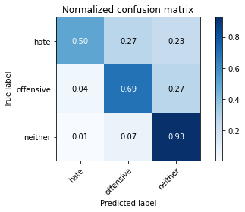

precision recall f1-score support

hate 0.73 0.50 0.59 96

offensive 0.77 0.69 0.73 355

neither 0.85 0.93 0.89 719

accuracy 0.82 1170

macro avg 0.78 0.71 0.74 1170

weighted avg 0.81 0.82 0.81 1170

average eval_loss: 0.5097693600139376, accuracy: 0.8205128205128205

training 4 epoch...

29.414797067642212 seconds used......

4 training finished! average train loss: 0.10193368220009291

evaluating...

Confusion matrix, without normalization

[[ 66 22 8]

[ 34 262 59]

[ 27 89 603]]

Normalized confusion matrix

[[0.6875 0.22916667 0.08333333]

[0.09577465 0.73802817 0.16619718]

[0.03755216 0.12378303 0.83866481]]

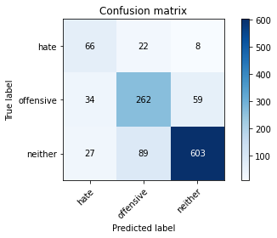

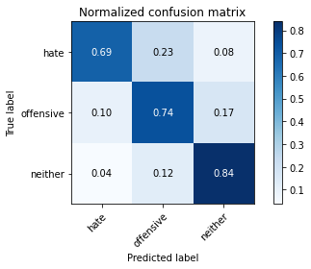

precision recall f1-score support

hate 0.52 0.69 0.59 96

offensive 0.70 0.74 0.72 355

neither 0.90 0.84 0.87 719

accuracy 0.80 1170

macro avg 0.71 0.75 0.73 1170

weighted avg 0.81 0.80 0.80 1170

average eval_loss: 0.7149289943025274, accuracy: 0.7957264957264957

training 5 epoch...

29.458381414413452 seconds used......

5 training finished! average train loss: 0.05588548478240577

evaluating...

Confusion matrix, without normalization

[[ 53 31 12]

[ 22 288 45]

[ 28 93 598]]

Normalized confusion matrix

[[0.55208333 0.32291667 0.125 ]

[0.06197183 0.81126761 0.12676056]

[0.03894298 0.12934631 0.83171071]]

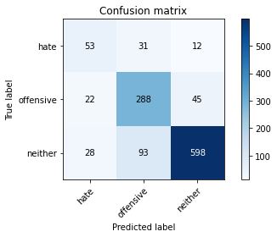

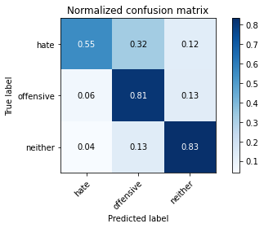

precision recall f1-score support

hate 0.51 0.55 0.53 96

offensive 0.70 0.81 0.75 355

neither 0.91 0.83 0.87 719

accuracy 0.80 1170

macro avg 0.71 0.73 0.72 1170

weighted avg 0.82 0.80 0.81 1170

average eval_loss: 0.809763089832613, accuracy: 0.8025641025641026

training 6 epoch...

29.483529329299927 seconds used......

6 training finished! average train loss: 0.03343403486043173

evaluating...

Confusion matrix, without normalization

[[ 74 14 8]

[ 50 259 46]

[ 54 91 574]]

Normalized confusion matrix

[[0.77083333 0.14583333 0.08333333]

[0.14084507 0.72957746 0.12957746]

[0.07510431 0.12656467 0.79833102]]

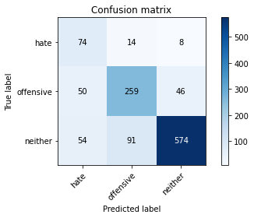

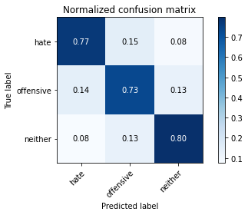

precision recall f1-score support

hate 0.42 0.77 0.54 96

offensive 0.71 0.73 0.72 355

neither 0.91 0.80 0.85 719

accuracy 0.78 1170

macro avg 0.68 0.77 0.70 1170

weighted avg 0.81 0.78 0.79 1170

average eval_loss: 1.0377388628104987, accuracy: 0.7752136752136752

training 7 epoch...

29.389520406723022 seconds used......

7 training finished! average train loss: 0.03806708433563845

evaluating...

Confusion matrix, without normalization

[[ 59 33 4]

[ 23 311 21]

[ 35 204 480]]

Normalized confusion matrix

[[0.61458333 0.34375 0.04166667]

[0.06478873 0.87605634 0.05915493]

[0.04867872 0.2837274 0.66759388]]

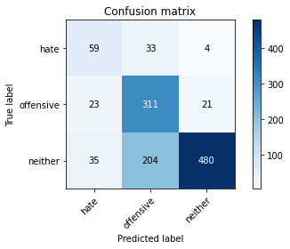

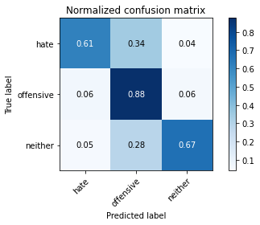

precision recall f1-score support

hate 0.50 0.61 0.55 96

offensive 0.57 0.88 0.69 355

neither 0.95 0.67 0.78 719

accuracy 0.73 1170

macro avg 0.67 0.72 0.68 1170

weighted avg 0.80 0.73 0.74 1170

average eval_loss: 1.2529175231012248, accuracy: 0.7264957264957265

training 8 epoch...

29.519230604171753 seconds used......

8 training finished! average train loss: 0.03735308486275011

evaluating...

Confusion matrix, without normalization

[[ 65 26 5]

[ 33 294 28]

[ 42 142 535]]

Normalized confusion matrix

[[0.67708333 0.27083333 0.05208333]

[0.09295775 0.82816901 0.07887324]

[0.05841446 0.19749652 0.74408901]]

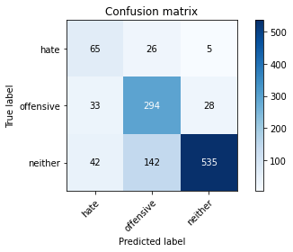

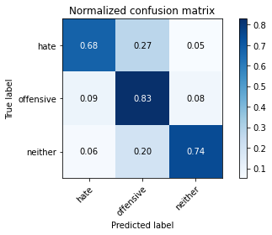

precision recall f1-score support

hate 0.46 0.68 0.55 96

offensive 0.64 0.83 0.72 355

neither 0.94 0.74 0.83 719

accuracy 0.76 1170

macro avg 0.68 0.75 0.70 1170

weighted avg 0.81 0.76 0.77 1170

average eval_loss: 1.0638084827085672, accuracy: 0.764102564102564

training 9 epoch...

29.407676935195923 seconds used......

9 training finished! average train loss: 0.03944536760033001

evaluating...

Confusion matrix, without normalization

[[ 65 23 8]

[ 28 295 32]

[ 31 138 550]]

Normalized confusion matrix

[[0.67708333 0.23958333 0.08333333]

[0.07887324 0.83098592 0.09014085]

[0.04311544 0.19193324 0.76495132]]

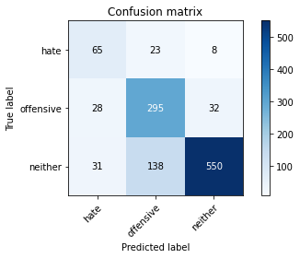

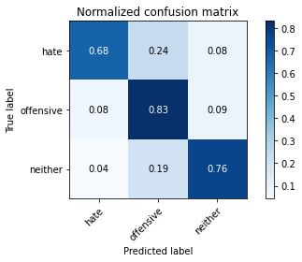

precision recall f1-score support

hate 0.52 0.68 0.59 96

offensive 0.65 0.83 0.73 355

neither 0.93 0.76 0.84 719

accuracy 0.78 1170

macro avg 0.70 0.76 0.72 1170

weighted avg 0.81 0.78 0.79 1170

average eval_loss: 0.976458597738864, accuracy: 0.7777777777777778

training 10 epoch...

29.63114047050476 seconds used......

10 training finished! average train loss: 0.02737151780997803

evaluating...

Confusion matrix, without normalization

[[ 64 22 10]

[ 31 271 53]

[ 28 106 585]]

Normalized confusion matrix

[[0.66666667 0.22916667 0.10416667]

[0.08732394 0.76338028 0.14929577]

[0.03894298 0.14742698 0.81363004]]

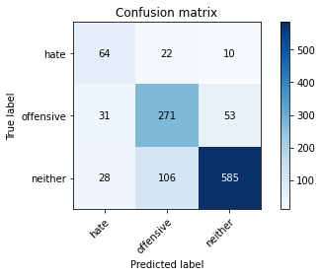

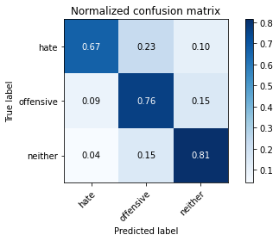

precision recall f1-score support

hate 0.52 0.67 0.58 96

offensive 0.68 0.76 0.72 355

neither 0.90 0.81 0.86 719

accuracy 0.79 1170

macro avg 0.70 0.75 0.72 1170

weighted avg 0.80 0.79 0.79 1170

average eval_loss: 0.86581683095734, accuracy: 0.7863247863247863

4 run......

training 1 epoch...

29.676461219787598 seconds used......

1 training finished! average train loss: 0.7808089623084435

evaluating...

Confusion matrix, without normalization

[[ 10 68 18]

[ 2 304 49]

[ 2 160 557]]

Normalized confusion matrix

[[0.10416667 0.70833333 0.1875 ]

[0.0056338 0.85633803 0.13802817]

[0.00278164 0.22253129 0.77468707]]

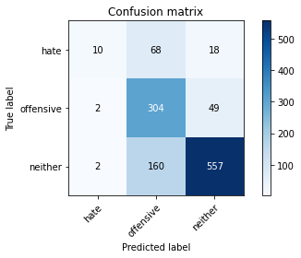

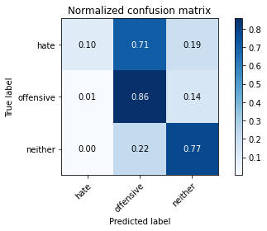

precision recall f1-score support

hate 0.71 0.10 0.18 96

offensive 0.57 0.86 0.69 355

neither 0.89 0.77 0.83 719

accuracy 0.74 1170

macro avg 0.73 0.58 0.57 1170

weighted avg 0.78 0.74 0.73 1170

average eval_loss: 0.5743118110349623, accuracy: 0.7444444444444445

training 2 epoch...

29.807791709899902 seconds used......

2 training finished! average train loss: 0.4741568784110057

evaluating...

Confusion matrix, without normalization

[[ 71 14 11]

[ 66 239 50]

[ 45 87 587]]

Normalized confusion matrix

[[0.73958333 0.14583333 0.11458333]

[0.18591549 0.67323944 0.14084507]

[0.06258693 0.12100139 0.81641168]]

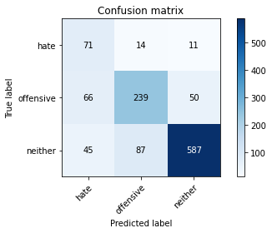

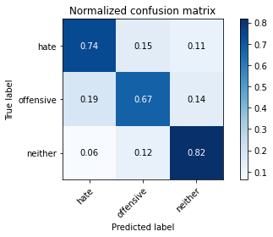

precision recall f1-score support

hate 0.39 0.74 0.51 96

offensive 0.70 0.67 0.69 355

neither 0.91 0.82 0.86 719

accuracy 0.77 1170

macro avg 0.67 0.74 0.69 1170

weighted avg 0.80 0.77 0.78 1170

average eval_loss: 0.555299932421264, accuracy: 0.7666666666666667

training 3 epoch...

29.66075611114502 seconds used......

3 training finished! average train loss: 0.214967844565996

evaluating...

Confusion matrix, without normalization

[[ 50 38 8]

[ 23 295 37]

[ 18 160 541]]

Normalized confusion matrix

[[0.52083333 0.39583333 0.08333333]

[0.06478873 0.83098592 0.10422535]

[0.02503477 0.22253129 0.75243394]]

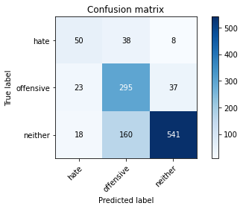

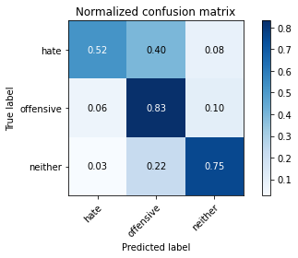

precision recall f1-score support

hate 0.55 0.52 0.53 96

offensive 0.60 0.83 0.70 355

neither 0.92 0.75 0.83 719

accuracy 0.76 1170

macro avg 0.69 0.70 0.69 1170

weighted avg 0.79 0.76 0.76 1170

average eval_loss: 0.7352652807356947, accuracy: 0.7572649572649572

training 4 epoch...

29.650145769119263 seconds used......

4 training finished! average train loss: 0.08232196368491994

evaluating...

Confusion matrix, without normalization

[[ 36 49 11]

[ 9 300 46]

[ 11 101 607]]

Normalized confusion matrix

[[0.375 0.51041667 0.11458333]

[0.02535211 0.84507042 0.12957746]

[0.01529903 0.14047288 0.84422809]]

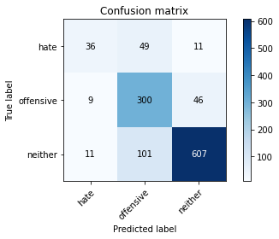

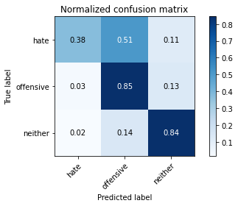

precision recall f1-score support

hate 0.64 0.38 0.47 96

offensive 0.67 0.85 0.75 355

neither 0.91 0.84 0.88 719

accuracy 0.81 1170

macro avg 0.74 0.69 0.70 1170

weighted avg 0.82 0.81 0.80 1170

average eval_loss: 0.7228604318984484, accuracy: 0.805982905982906

training 5 epoch...

29.64564299583435 seconds used......

5 training finished! average train loss: 0.039485591473445915

evaluating...

Confusion matrix, without normalization

[[ 59 29 8]

[ 32 284 39]

[ 31 115 573]]

Normalized confusion matrix

[[0.61458333 0.30208333 0.08333333]

[0.09014085 0.8 0.10985915]

[0.04311544 0.15994437 0.79694019]]

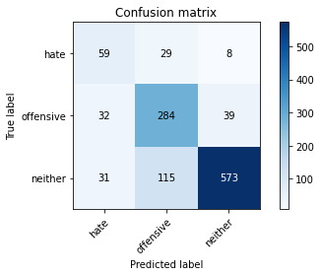

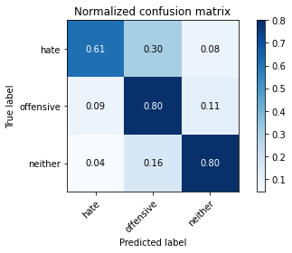

precision recall f1-score support

hate 0.48 0.61 0.54 96

offensive 0.66 0.80 0.73 355

neither 0.92 0.80 0.86 719

accuracy 0.78 1170

macro avg 0.69 0.74 0.71 1170

weighted avg 0.81 0.78 0.79 1170

average eval_loss: 0.9540058765876092, accuracy: 0.7829059829059829

training 6 epoch...

29.59262704849243 seconds used......

6 training finished! average train loss: 0.04772275521416958

evaluating...

Confusion matrix, without normalization

[[ 40 32 24]

[ 13 280 62]

[ 7 84 628]]

Normalized confusion matrix

[[0.41666667 0.33333333 0.25 ]

[0.03661972 0.78873239 0.17464789]

[0.00973574 0.11682893 0.87343533]]

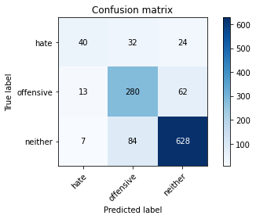

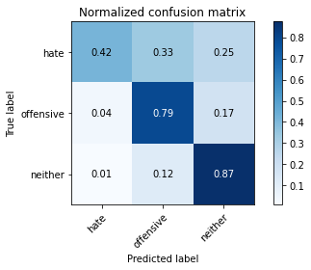

precision recall f1-score support

hate 0.67 0.42 0.51 96

offensive 0.71 0.79 0.75 355

neither 0.88 0.87 0.88 719

accuracy 0.81 1170

macro avg 0.75 0.69 0.71 1170

weighted avg 0.81 0.81 0.81 1170

average eval_loss: 0.7836496516809626, accuracy: 0.8102564102564103

training 7 epoch...

29.550734519958496 seconds used......

7 training finished! average train loss: 0.02192657919621501

evaluating...

Confusion matrix, without normalization

[[ 61 25 10]

[ 29 286 40]

[ 17 125 577]]

Normalized confusion matrix

[[0.63541667 0.26041667 0.10416667]

[0.08169014 0.8056338 0.11267606]

[0.02364395 0.17385257 0.80250348]]

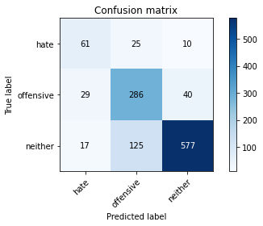

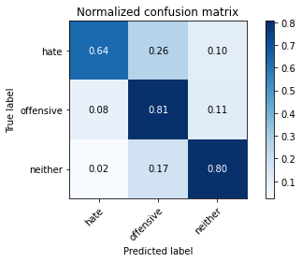

precision recall f1-score support

hate 0.57 0.64 0.60 96

offensive 0.66 0.81 0.72 355

neither 0.92 0.80 0.86 719

accuracy 0.79 1170

macro avg 0.72 0.75 0.73 1170

weighted avg 0.81 0.79 0.80 1170

average eval_loss: 0.961632429038064, accuracy: 0.7897435897435897

training 8 epoch...

29.533714532852173 seconds used......

8 training finished! average train loss: 0.03231605249236917

evaluating...

Confusion matrix, without normalization

[[ 43 48 5]

[ 16 297 42]

[ 28 125 566]]

Normalized confusion matrix

[[0.44791667 0.5 0.05208333]

[0.04507042 0.83661972 0.11830986]

[0.03894298 0.17385257 0.78720445]]

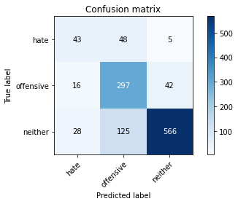

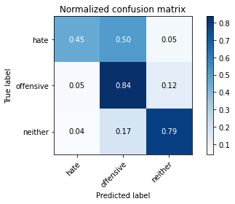

precision recall f1-score support

hate 0.49 0.45 0.47 96

offensive 0.63 0.84 0.72 355

neither 0.92 0.79 0.85 719

accuracy 0.77 1170

macro avg 0.68 0.69 0.68 1170

weighted avg 0.80 0.77 0.78 1170

average eval_loss: 1.0039075269537456, accuracy: 0.7743589743589744

training 9 epoch...

29.573867797851562 seconds used......

9 training finished! average train loss: 0.028782267189504076

evaluating...

Confusion matrix, without normalization

[[ 44 35 17]

[ 15 281 59]

[ 8 90 621]]

Normalized confusion matrix

[[0.45833333 0.36458333 0.17708333]

[0.04225352 0.7915493 0.16619718]

[0.01112656 0.12517385 0.86369958]]

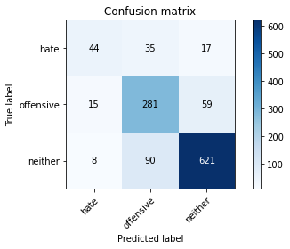

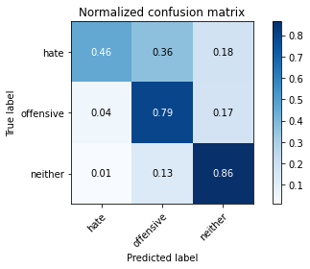

precision recall f1-score support

hate 0.66 0.46 0.54 96

offensive 0.69 0.79 0.74 355

neither 0.89 0.86 0.88 719

accuracy 0.81 1170

macro avg 0.75 0.70 0.72 1170

weighted avg 0.81 0.81 0.81 1170

average eval_loss: 0.9142358478284993, accuracy: 0.8085470085470086

training 10 epoch...

29.54621434211731 seconds used......

10 training finished! average train loss: 0.030227357600196205

evaluating...

Confusion matrix, without normalization

[[ 51 27 18]

[ 29 255 71]

[ 18 65 636]]

Normalized confusion matrix

[[0.53125 0.28125 0.1875 ]

[0.08169014 0.71830986 0.2 ]

[0.02503477 0.09040334 0.88456189]]

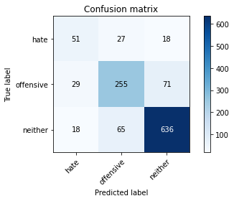

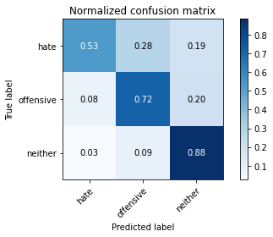

precision recall f1-score support

hate 0.52 0.53 0.53 96

offensive 0.73 0.72 0.73 355

neither 0.88 0.88 0.88 719

accuracy 0.81 1170

macro avg 0.71 0.71 0.71 1170

weighted avg 0.80 0.81 0.80 1170

average eval_loss: 0.9119600480959072, accuracy: 0.8051282051282052

5 run......

training 1 epoch...

29.52692413330078 seconds used......

1 training finished! average train loss: 0.7435293570160866

evaluating...

Confusion matrix, without normalization

[[ 45 36 15]

[ 20 279 56]

[ 34 94 591]]

Normalized confusion matrix

[[0.46875 0.375 0.15625 ]

[0.05633803 0.78591549 0.15774648]

[0.0472879 0.13073713 0.82197497]]

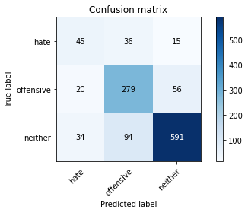

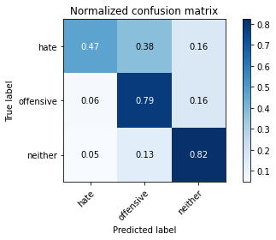

precision recall f1-score support

hate 0.45 0.47 0.46 96

offensive 0.68 0.79 0.73 355

neither 0.89 0.82 0.86 719

accuracy 0.78 1170

macro avg 0.68 0.69 0.68 1170

weighted avg 0.79 0.78 0.79 1170

average eval_loss: 0.5320701775914531, accuracy: 0.782051282051282

training 2 epoch...

29.505658864974976 seconds used......

2 training finished! average train loss: 0.39555530899610275

evaluating...

Confusion matrix, without normalization

[[ 65 26 5]

[ 32 272 51]

[ 42 103 574]]

Normalized confusion matrix

[[0.67708333 0.27083333 0.05208333]

[0.09014085 0.76619718 0.14366197]

[0.05841446 0.14325452 0.79833102]]

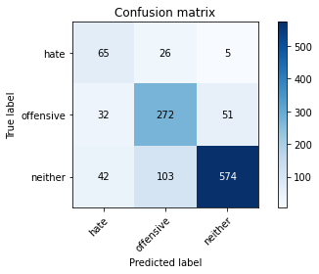

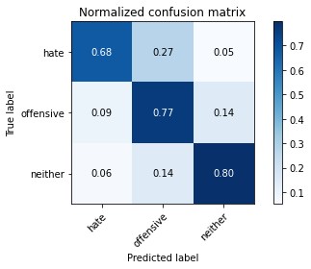

precision recall f1-score support

hate 0.47 0.68 0.55 96

offensive 0.68 0.77 0.72 355

neither 0.91 0.80 0.85 719

accuracy 0.78 1170

macro avg 0.69 0.75 0.71 1170

weighted avg 0.80 0.78 0.79 1170

average eval_loss: 0.5450306371864626, accuracy: 0.7786324786324786

training 3 epoch...

29.46488857269287 seconds used......

3 training finished! average train loss: 0.16072901564602476

evaluating...

Confusion matrix, without normalization

[[ 48 39 9]

[ 17 305 33]

[ 19 158 542]]

Normalized confusion matrix

[[0.5 0.40625 0.09375 ]

[0.04788732 0.85915493 0.09295775]

[0.02642559 0.21974965 0.75382476]]

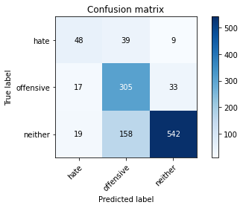

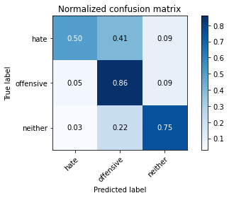

precision recall f1-score support

hate 0.57 0.50 0.53 96

offensive 0.61 0.86 0.71 355

neither 0.93 0.75 0.83 719

accuracy 0.76 1170

macro avg 0.70 0.70 0.69 1170

weighted avg 0.80 0.76 0.77 1170

average eval_loss: 0.7773939747426469, accuracy: 0.7649572649572649

training 4 epoch...

29.605244874954224 seconds used......

4 training finished! average train loss: 0.07754799294828747

evaluating...

Confusion matrix, without normalization

[[ 53 34 9]

[ 19 288 48]

[ 20 131 568]]

Normalized confusion matrix

[[0.55208333 0.35416667 0.09375 ]

[0.05352113 0.81126761 0.13521127]

[0.02781641 0.1821975 0.78998609]]

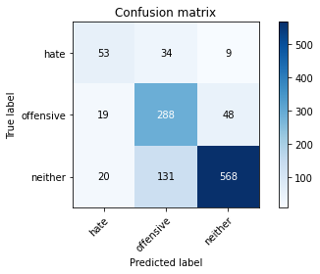

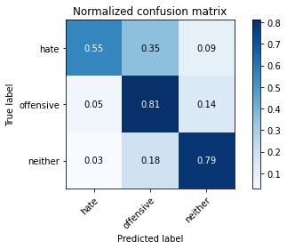

precision recall f1-score support

hate 0.58 0.55 0.56 96

offensive 0.64 0.81 0.71 355

neither 0.91 0.79 0.85 719

accuracy 0.78 1170

macro avg 0.71 0.72 0.71 1170

weighted avg 0.80 0.78 0.78 1170

average eval_loss: 0.7791978952048694, accuracy: 0.7769230769230769

training 5 epoch...

29.558873653411865 seconds used......

5 training finished! average train loss: 0.0414044138630673

evaluating...

Confusion matrix, without normalization

[[ 53 33 10]

[ 21 287 47]

[ 18 123 578]]

Normalized confusion matrix

[[0.55208333 0.34375 0.10416667]

[0.05915493 0.8084507 0.13239437]

[0.02503477 0.17107093 0.8038943 ]]

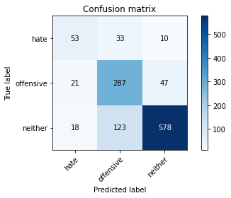

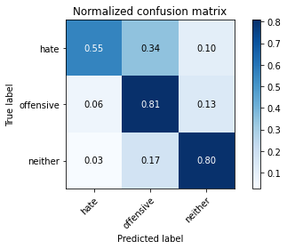

precision recall f1-score support

hate 0.58 0.55 0.56 96

offensive 0.65 0.81 0.72 355

neither 0.91 0.80 0.85 719

accuracy 0.78 1170

macro avg 0.71 0.72 0.71 1170

weighted avg 0.80 0.78 0.79 1170

average eval_loss: 0.8729405425394238, accuracy: 0.7846153846153846

training 6 epoch...

29.574728965759277 seconds used......

6 training finished! average train loss: 0.029820714930209737

evaluating...

Confusion matrix, without normalization

[[ 42 40 14]

[ 12 291 52]

[ 13 111 595]]

Normalized confusion matrix

[[0.4375 0.41666667 0.14583333]

[0.03380282 0.81971831 0.14647887]

[0.01808067 0.15438108 0.82753825]]

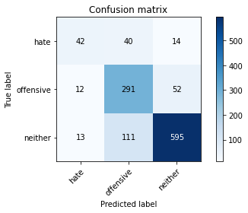

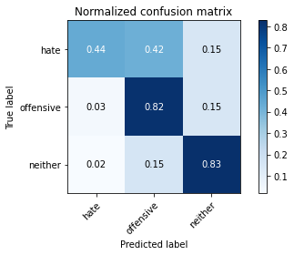

precision recall f1-score support

hate 0.63 0.44 0.52 96

offensive 0.66 0.82 0.73 355

neither 0.90 0.83 0.86 719

accuracy 0.79 1170

macro avg 0.73 0.69 0.70 1170

weighted avg 0.80 0.79 0.79 1170

average eval_loss: 1.0134018317843645, accuracy: 0.7931623931623931

training 7 epoch...

29.517189025878906 seconds used......

7 training finished! average train loss: 0.027142840847470023

evaluating...

Confusion matrix, without normalization

[[ 38 45 13]

[ 7 298 50]

[ 6 118 595]]

Normalized confusion matrix

[[0.39583333 0.46875 0.13541667]

[0.01971831 0.83943662 0.14084507]

[0.00834492 0.16411683 0.82753825]]

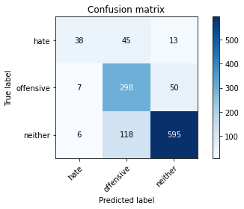

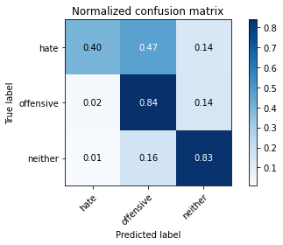

precision recall f1-score support

hate 0.75 0.40 0.52 96

offensive 0.65 0.84 0.73 355

neither 0.90 0.83 0.86 719

accuracy 0.80 1170

macro avg 0.77 0.69 0.70 1170

weighted avg 0.81 0.80 0.80 1170

average eval_loss: 0.9912848245999697, accuracy: 0.7957264957264957

training 8 epoch...

29.505876302719116 seconds used......

8 training finished! average train loss: 0.0318225464227278

evaluating...

Confusion matrix, without normalization

[[ 57 27 12]

[ 24 276 55]

[ 20 97 602]]

Normalized confusion matrix

[[0.59375 0.28125 0.125 ]

[0.06760563 0.77746479 0.15492958]

[0.02781641 0.1349096 0.83727399]]

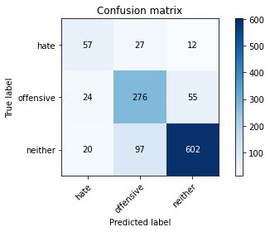

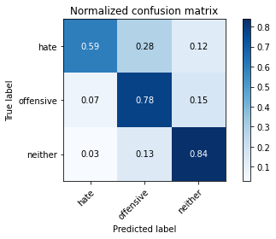

precision recall f1-score support

hate 0.56 0.59 0.58 96

offensive 0.69 0.78 0.73 355

neither 0.90 0.84 0.87 719

accuracy 0.80 1170

macro avg 0.72 0.74 0.73 1170

weighted avg 0.81 0.80 0.80 1170

average eval_loss: 0.9540483915183883, accuracy: 0.7991452991452992

training 9 epoch...

29.559304237365723 seconds used......

9 training finished! average train loss: 0.029676856010971673

evaluating...

Confusion matrix, without normalization

[[ 57 27 12]

[ 26 286 43]

[ 22 141 556]]

Normalized confusion matrix

[[0.59375 0.28125 0.125 ]

[0.07323944 0.8056338 0.12112676]

[0.03059805 0.1961057 0.77329624]]

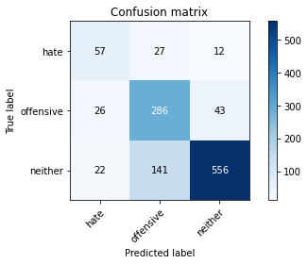

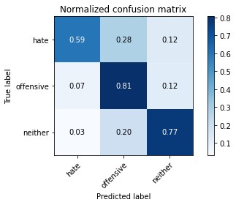

precision recall f1-score support

hate 0.54 0.59 0.57 96

offensive 0.63 0.81 0.71 355

neither 0.91 0.77 0.84 719

accuracy 0.77 1170

macro avg 0.69 0.72 0.70 1170

weighted avg 0.79 0.77 0.77 1170

average eval_loss: 1.0359988795056687, accuracy: 0.7683760683760684

training 10 epoch...

29.500948190689087 seconds used......

10 training finished! average train loss: 0.016322118088189595

evaluating...

Confusion matrix, without normalization

[[ 61 24 11]

[ 31 276 48]

[ 25 121 573]]

Normalized confusion matrix

[[0.63541667 0.25 0.11458333]

[0.08732394 0.77746479 0.13521127]

[0.03477051 0.16828929 0.79694019]]

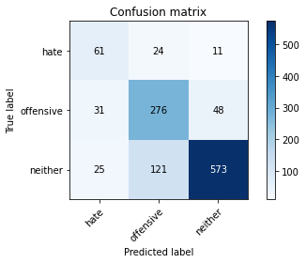

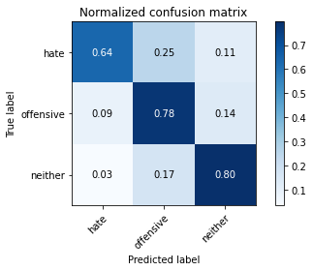

precision recall f1-score support

hate 0.52 0.64 0.57 96

offensive 0.66 0.78 0.71 355

neither 0.91 0.80 0.85 719

accuracy 0.78 1170

macro avg 0.69 0.74 0.71 1170

weighted avg 0.80 0.78 0.78 1170

average eval_loss: 1.092503631700588, accuracy: 0.7777777777777778